|  |
| --- |
| **GREYSTONE INVESTMENTS LTD**  **COMPANY PROFILE**  **AND**  **WORK EXPERIENCE**  **Plot 989, Nakulabye Block 257, Kitala Plaza**  **TELE: +256-772461511/+256-702461511**  **Email:** [**jbarohooza@yahoo.com**](mailto:jbarohooza@yahoo.com)  **UGANDA**   1. **INTRODUCTION:**   **Summarized company information and Company Documents**  Greystone Investments Limited is a Civil and Building Works Company. We first registered Our Company as M/s Ishaka Muhereza Workshop & Building Construction Ltd that was registed/incorporated on 25 May 2009 , but changed names to M/S Greystone Investments Ltd on 12th July 2013. Therefore, the new Company takes on the Liabilities and Experience of the Old Company.  The Company was first Registered as Ishaka Muhereza and was incorporated/registered in 2009 in Uganda and organized all its Administrative staffs, Engineers, as well as Technicians.  The company became functional and effective in construction work of road as Ishaka- Muhereza Workshop in 2009.  It established the Managing Director as Mr. Julius Barohooza with the administration experience of over thirteen years experienced engineers and Technical Staff.  The company is established and registered in accordance with the laws of Uganda.  The favorable investment policy and the incentive packages encouraged it to commit its resource to form the company thereby, contribute the part overall economic development of the Country. |

**STRUCTURE AND ORGANIZATION**

|  |  |  |
| --- | --- | --- |
| 1. | Company Name: | GREYSTONE INVESTMENTS LIMITED |
| 2. | Description of Company: | **BUILDING AND CIVIL ENGINEERING CONTRACTORS** |
| 3. | Physical Location: | **HEAD OFFICE**  **Plot 989, Nakulabye Block 257, Kitala Plaza**  **KAMPALA** |
| 4. | Postal Address: | **P.O. Box 323143, Kampala, UGANDA.** |
| 5. | Telephone No.  Tele fax No.  E-mail address: | **+256 –772461511/+256-702461511**  [**jbarohooza@yahoo.com**](mailto:jbarohooza@yahoo.com) |
| 6. | Countries and Year Incorporated: | **UGANDA, 2009** |
| 7. | Directors: - |  |
|  | (a) Barohooza Julius: | **Managing Director has worked in the Construction Industry for over 12 years.** |
|  | (b) Agaba Damalie  (c ) Byamugisha Damson | **Director has an experience of over 7 years in the administration and management of Engineering Operations.**  **Director has an experience of over 6 years in Civil and Building works.** |
|  |  |  |
| 8. | Experience: | **13 Years of Experience as Civil works, Building and Road Works Contractors.** |
| 9. | Description of the Company Activities:- |  |
|  |  | * **Highways, Urban and Community Road Construction and Bridges** * **Construction of Parking Yards & Car Parks** * **Building and Civil Engineering Works** * **Steel Fabrication** * **Urban and Rural water supply and Sewerage construction Services** * **Carpentry and Joinery** * **Water proofing of flat roofs** * **Plumbing works** * **General Supply of Goods and Services** |
| 10. Contractor Class: B+INSURERS | | |
| 1 | National Insurance Corporation: | P.O. Box 7134, Kampala. Tel: 041 258001/10, Fax: 259925 |
| 2 | Sanlam General Insurance: | P.O. Box 24256, Kampala. Tel: +256312264273 |
| 3 | Excel Insurance Company Ltd: | P.O. Box 7213, Kampala. Tel: 041348595/6/7, Fax: 342304 |

**FINANCIAL STATUS**

|  |  |  |
| --- | --- | --- |
| 1. | **CAPITAL STRUCTURE:-** |  |
|  | The Company has an authorized Share Capital of Ug.Shs.10,000,000/= | |
| 2. | **FIXED ASSETS:-** |  |
|  | a. Residential Building: | Plot 1160, Mengo - Nakulabye, Rubaga Division  Kampala |
|  | b. Residential Building:  c. 2 Acres of Residential land : | Plot No.19, Block 39.Mbarara, Mbarara - Kasese Road  Bushenyi Municipal Council. |
|  |  |  |
| 3. | BANKERS: - |  |
|  | a. Equity Bank Uganda Limited,  Katwe Branch, | Kampala,  **Kampala.**  Tel: +256772290000 |
|  | b. Commercial Bank of Africa,  Plot 10 Kafu Rd, Nakasero,  Kampala | P.O. Box 24327,  **Kampala.**  Tel: +256 312188400 |
|  | The Company enjoys Credit Facilities from our main Bankers;  M/s Exim Bank and Equity Bank | |
| 4. | TAX IDENTIFICATION: - |  |
|  |  | TIN No. 1001071568 |

5. **AUDITORS**

SAKKAY & Company Certified Public Accountants of Uganda

P. O. Box 710, Mbarara

Tel: 0782-529713/0703789038

**COMPANY MISSION**

**MISSION STATEMENT: -**

Greystone Investments Limited is dedicated to providing excellent construction services in Uganda and in the East African Region. Our ability to succeed is based on a solid commitment to values of integrity and solidarity while ensuring quality, timely completion and safety standards.

**Vision: -**

We aim to be amongst the top indigenous construction company in Uganda and the East African Region within the next five years.

**Mission: -**

* We are dedicated to provide high standard services and products that are fit for purpose.
* We aim at satisfying our clients by providing best value for money.
* We believe that our development is strongly related to the development of our human resources through training.
* We are dedicated to safety, quality and preserving the environment.

We promote an environment of competitiveness amongst our employees to promote their sense of leadership and team working.

**ANNUAL TURNOVER OVER THE PAST 3 YEARS**

|  |  |  |
| --- | --- | --- |
| **Year** | **Total Annual Volume of Work Performed**  **UGX** | **USD Equivalent** |
| 2021 | 4,896,073,406 | 1,305,619 |
| 2020 | 5,969,778,670 | 1,591,945 |
| 2019 | 6,127,033,919 | 1,633,897 |
| **Average Annual Turn over** | **5,664,295,331** | **4,531,461** |

**RESOURCES: PERSONNEL**

1. **Number of Staff:**
   * Directors and Management staff: 5

* + Administrative staff 2
  + Technical staff: 10
  + Support Staff: 15

**Total**   **32**

**2.** **Company Directors**

|  |  |  |  |  |
| --- | --- | --- | --- | --- |
| **S/NO.** | **NAMES OF DIRECTORS** | **NATIONALITY** | **EXPERIENCE** | **QUALIFICATION** |
| 1 | BAROHOOZA JULIUS | Ugandan | 13 | B.A Accounting |
| 2 | AGABA DAMALIE | Ugandan | 9 | Diploma in Marketing |
| 3 | BYAMUGISHA DAMSON | Ugandan | 5 | B.Sc. (Civil Eng.) |

1. **. Key** **Personnel**

|  |  |  |  |  |  |  |
| --- | --- | --- | --- | --- | --- | --- |
| **Position/Name** | **Nationality** | **Age** | **Qualification** | **General Experience in proposed position** | **Years of experience (with the company)** | **Major works Handled (project/value)** |
| **Contracts Manager**  ISOOBA JULIUS | Ugandan | 43 | Bsc. Civil Engineering | 14 | 9 | 2BN TO 20 billion (UGX) |
| **SITE ENGINEERS**  JIMMY ORECH ODONGO  ANATOLI MUBIRO | Ugandan  Ugandan | 42  39 | Bsc. Civil Engineering,  Bsc. Civil Engineering | 12  8 | 5  4 | 2BN TO 10 Billion (UGX)  2B TO 10 Billion (UGX) |
| **SITE FOREMEN/Civil & Building works**  OJULU STEPHEN  BWINI BULAIMU  TWIJUKYE EDMUND  BYAMUGISHA DAMSON | Ugandan  Ugandan  Ugandan  Ugandan | 38  36  39  28 | Bsc. Civil  Engineering/  Bsc. Civil Engineering  Bsc. Civil Engineering  Bsc. Civil Engineering | 9  10  10  4 | 3  3  3  3 | 1BN TO 4Billion (UGX)  1-3 Billion (UGX)  1-3Billion (UGX)  Up to 1 Billion |
| **PLANTS MANAGER**  WAKABI FRED | Ugandan | 38 | Ordinary Diploma in mechanical engineering | 10 | 5 | Up to 1 Billion |
| **ENVIRONMENTAL OFFICERS**  NATURINDA NICHOLAS  IRUPIA SYLVIA | Ugandan  Ugandan | 34  32 | Bachelors of Arts in Environments  Bachelors of Arts in Environments | 5  4 | 3  2 | Up to 1 Billion  UP TO 1 Billion |

**RESOURCES: EQUIPMENT AND FACILITIES**

|  |  |  |  |
| --- | --- | --- | --- |
| **Item of Equipment** | **Description, make and age (years)** | **Conditions (new, good, poor) and number available** | **Owned, Hire, leased (from whom? or to be purchased (from whom?)** |
| **EARTH MOVING: -** |  |  |  |
| 1. Grader 2. Bull Dozer 3. Excavator 4. Roller | CAT 120H  Caterpillar,966C  Caterpillar  Dynapac | Good, 2 No.  Good, 4 No.  Good, 8 No.  Good, 2 No. | 1 Owned , 1Leased  Leased from BLD Consults  1Owned , 07 Leased  1Owned , 1 leased |
| **EQUIPMENT** |  |  |  |
| Tower Crane, | Type E 401, 3T, 45m Height; 36m jib | Good, 1 No. | Leased from Mr.Fred Kalanzi |
| **CONCRETE PLANT: -** |  |  |  |
| Concrete Mixer Ltr.350 | Lombading Model 90 | New, 4 No. | Owned |
| Precast Concrete Moulds |  | Assorted | Owned |
| Self-Loading Mixers 450 Ltr. | PH & TS II Engine | Good, 3 No. | Owned |
| Small Mixers |  | New, 5 No. | Owned |
| Diesel/Electric/Concrete Vibrators | 1990 & 1998 Honda | Good, 10No. | Owned |
| Concrete Cube Moulds |  | Assorted | Owned |
| **ELECTRO-MECHANICAL EQUIPMENT:** |  |  | Owned |
| Dewatering pump, 1999, Japan |  | Good, 2 No. | Owned |
| Diesel Generator 22 KVA | LPW3 | New, 1 No. | Owned |
| Diesel Compressor 125/175 complete with 2 hammers | Duetz Engine Model 1990 | New, 3 No. | Owned |
| Jumping Compactors |  | Good, 8 No. | Owned |
| Plate Compactors | 1995 Honda/Briggs & Stratton | New, Good, 3 No | Owned |
| Vibrator Roller 2 ton, Pedestrian | Hertz Engine, 1989 | Good, 2 No. | Owned |
| Concrete Multi Block Making  Machine 200 x 200 x 400mm Capacity | Dapta gear – Model 1996, Ratio 35 – 1 | Good, 4 No. | Owned |
| Double Drum Roller 10 ton (Drive) Bomag BW 80 AD |  | New, 2 No. | Leased from Nippon Parts Ltd |
| **WORKSHOP EQUIPMENT: -** |  |  |  |
| Full Equipped Carpentry Workshop |  | Good, 1 No. | Owned |
| Welding (Generator) | 50 KVA | Good, 1 Set | Owned |
| Welding Machine 300 Amp | Double Racer | Good, 4 No. | Owned |
| Hoisting Equipment |  | 2 sets | Owned |
| **VEHICLES: -** |  |  | Owned |
| Pick Ups, Nissan Datsun, 1-2 Tons | 1999 & 1998 | Good, 4 No. | Owned |
| **TIPPERS & SITE DUMPERS:-** |  |  |  |
| Tipper Truck, 25tons Mercedes Benz | 2020 Model | Good, 18 No. | Leased from kireka Lorry drivers |
| Tipper Truck, 7ton ISUZU | 1992 Model | Good, 2 No. | Owned |
| 5 Ton Flat Bed, ISUZU |  | Good, 2 No. | Owned |
| Tipper Truck 15 ton ISUZU | 1988 Model | Good, 1 No. | Owned |
| Dump Trucks | 2019 Model | Good ,13No | Leased from Double Q |
| Dump Trucks | 2018 Model | Good ,4No | Leased from M/s Dhalwa Electrical centre ltd |
| Self-Loader Mitsubishi (ISUZU) 4 ton | 1990 Model | Good, 1 No. | Owned |
| Site Dumper 1 Ton | PHII Model 89 | Good, 1 No. | Owned |
| Site Dumper 2 Ton |  | Good, 3No. | Owned |
| **GENERAL: -** |  |  | Owned |
| Standard Steel Scaffolding | Assorted | Good, 4000m2 | Owned |
| Metal Fabrication Equipment |  | Good, 2 No. | Owned |
| Masonry Tools | Assorted | Good | Owned |
| Plumbing Tools/Fitters Tools | Assorted | Good, 5 Set | Owned |
| Pressure Testing Equipment | Assorted | Good, 3 Set | Owned |
| Concrete Cutter/Asphalt | 1998 Honda | New, 1 No. | Owned |
| Dumpy Level | Wild | Good, 4 No. | Owned |
| Theodolite | Wild | Good, 2 No. | Owned |
| Assorted tower rigging equipment |  | Good, Lot | owned |

***PICTURES OF SOME OF THE EQUIPMENTS FOR GREYSTONE INVESTMENTS LIMITED***

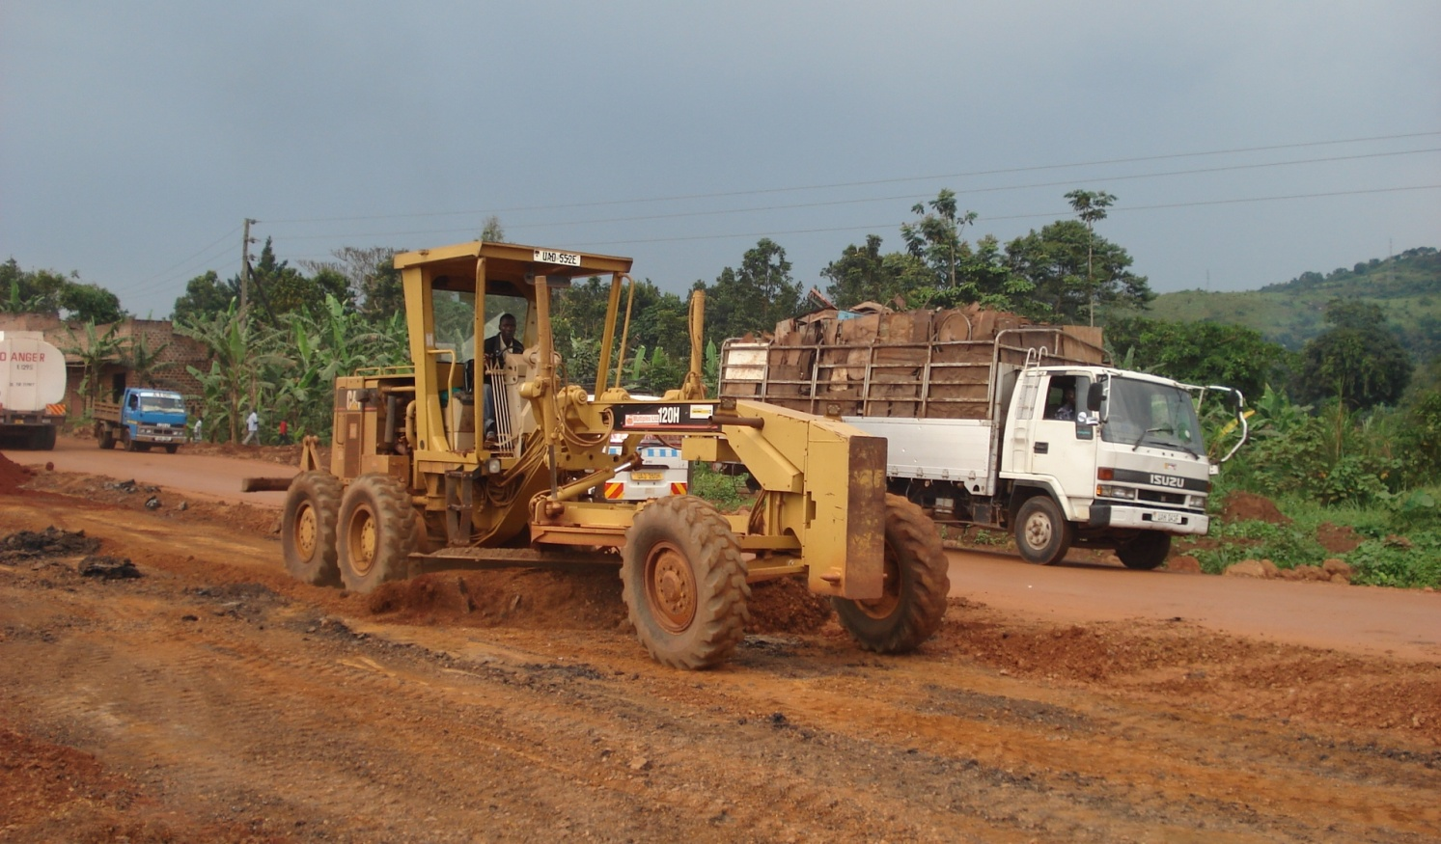

***Leased Caterpillar motor Grader 120H***

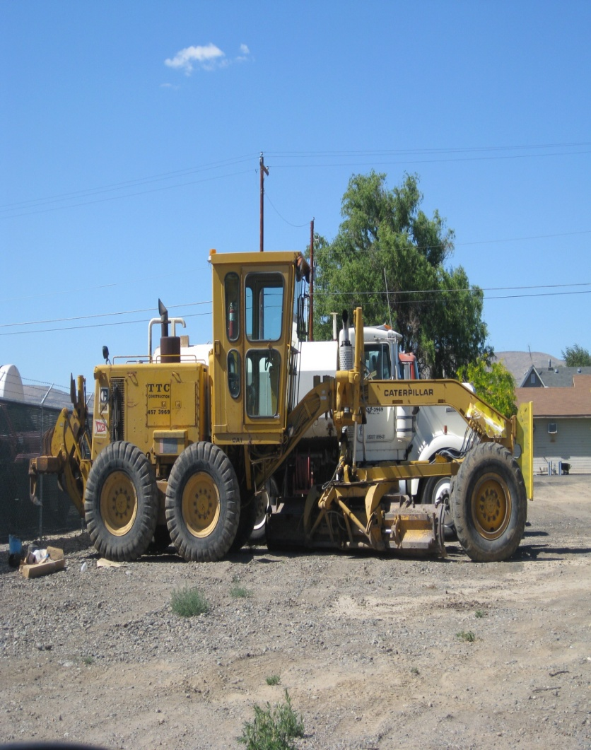

***Leased Caterpillar motor Grader 140G***

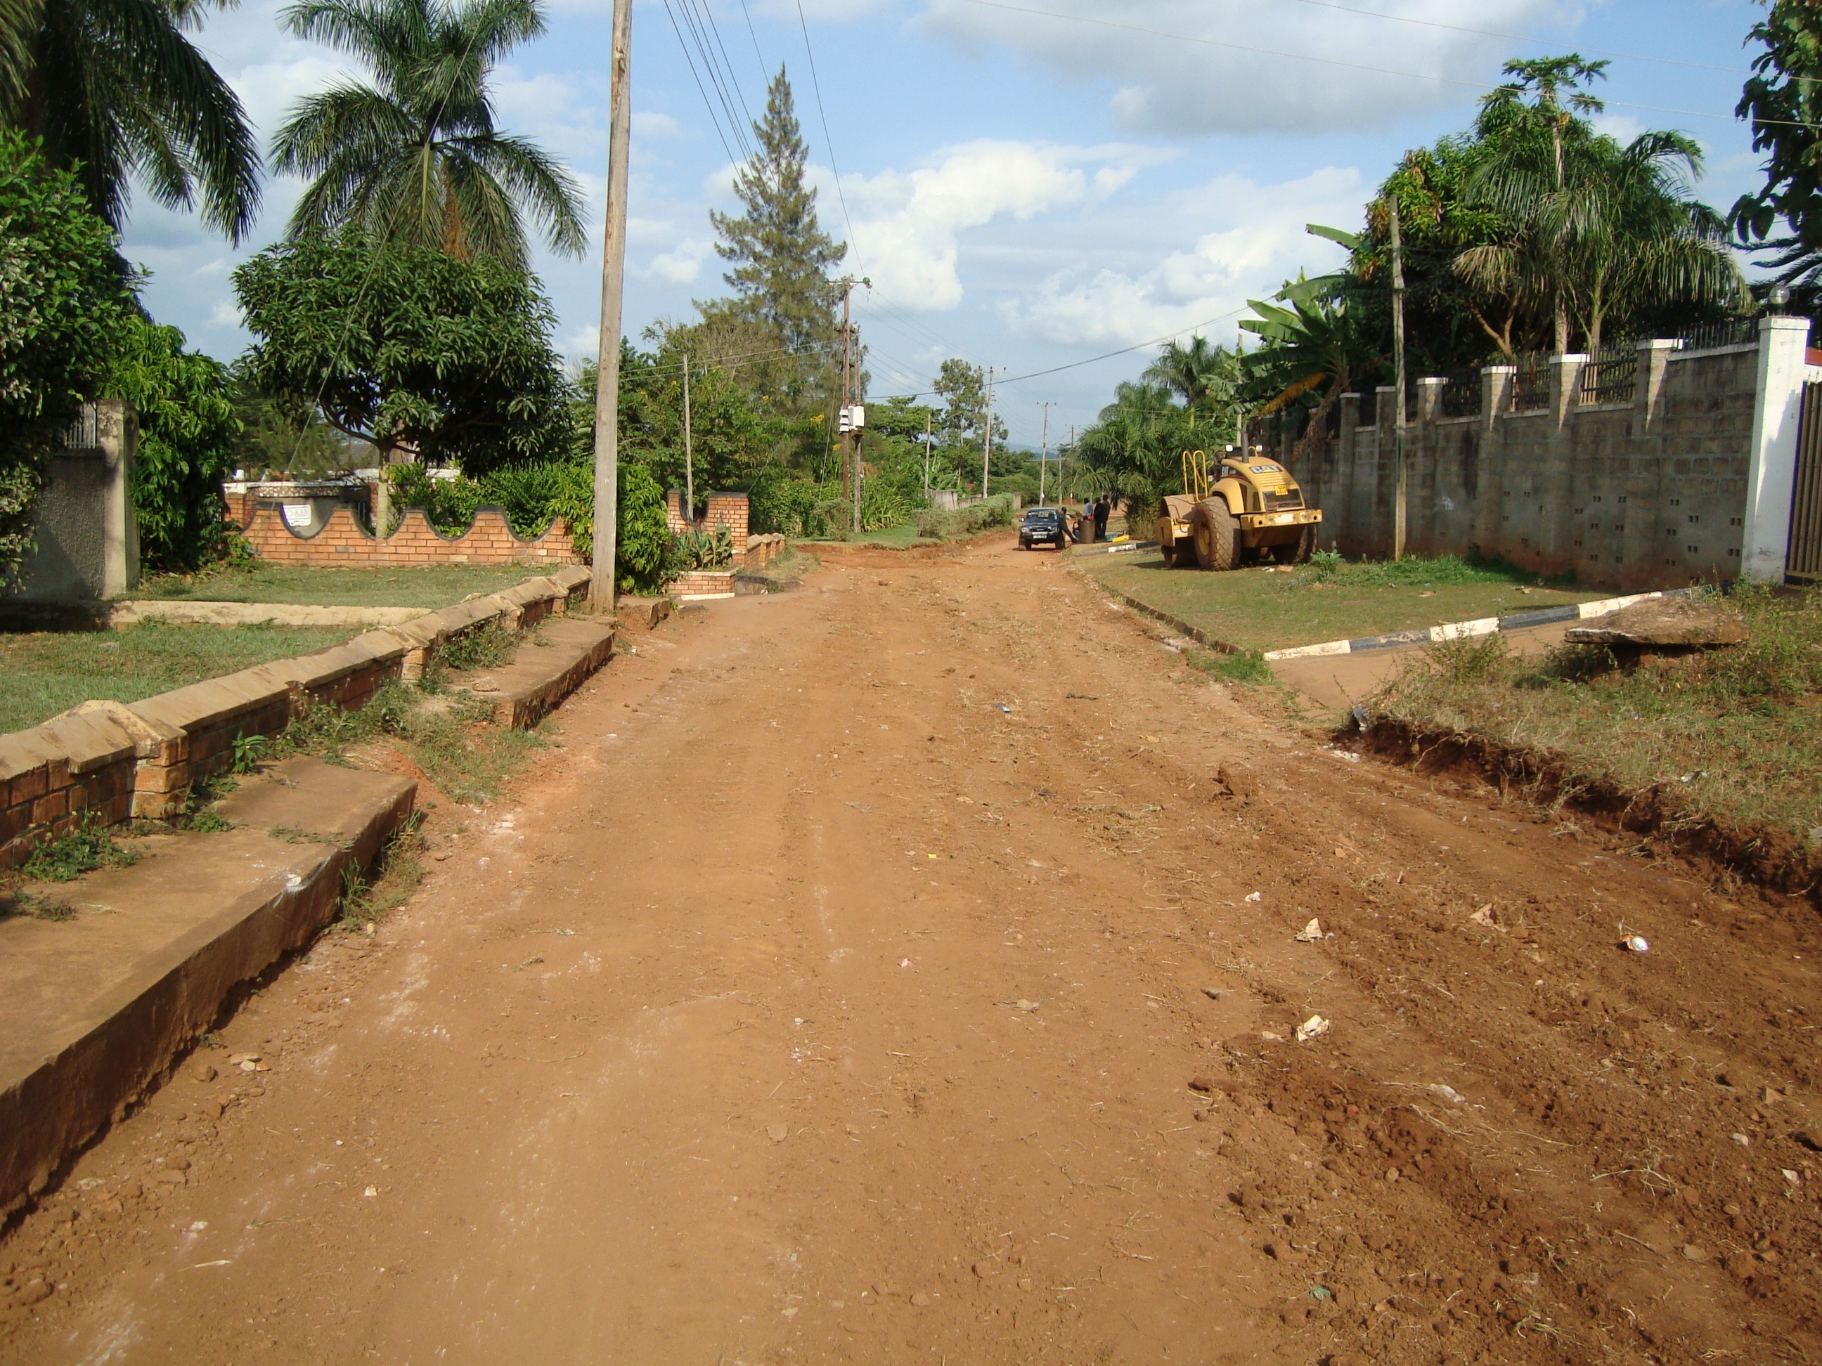

***Leased 15ton Vibratory Roller for Compaction***

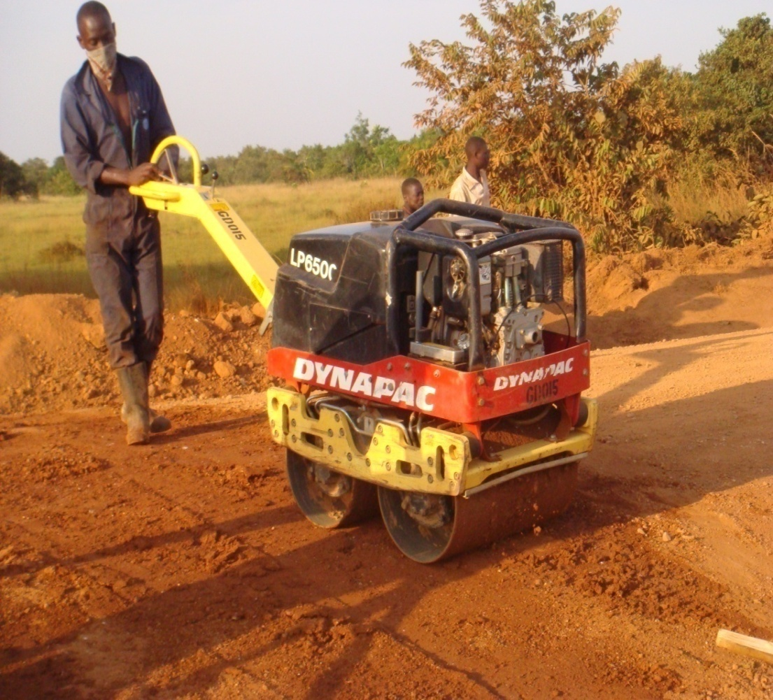

***Owned Pedestrian Roller for Drainage and Car Park works***

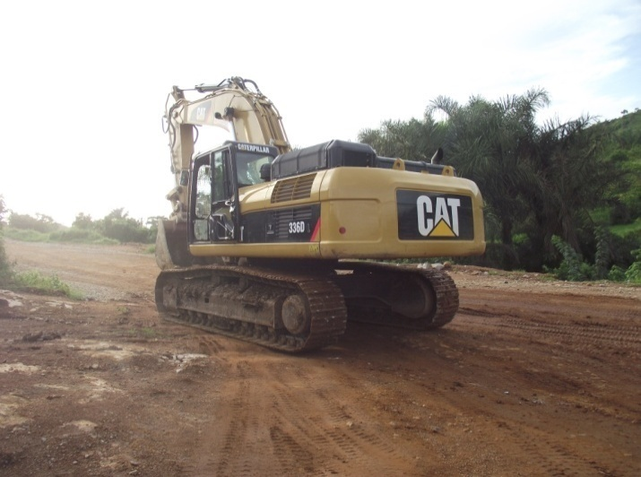

***Leased Caterpillar Excavator of 2.5m3***

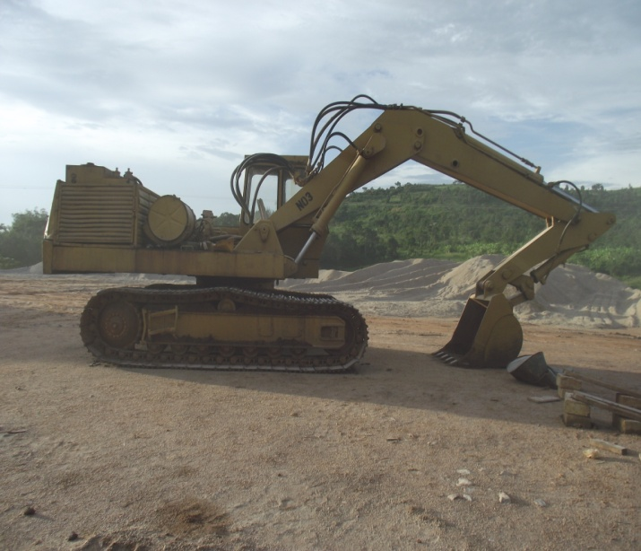

***Leased Caterpillar Excavator of 2***

**EXPERIENCE: RELEVANT PROJECTS COMPLETED**

**SOME OF THE PROJECT UNDERTAKEN DURING THE LAST 10 YEARS**

|  |  |  |  |  |
| --- | --- | --- | --- | --- |
| **Starting**  **Year** | **Ending**  **Year** | **Years** | **Contract Identification** | **Role of**  **Bidder** |
| 11th October 2021 | 23rd May 2022 | 8 months | **Contract Name:** construction &Rehabilitation of Kagongi-Buwama Community Access Road (33km) Contract Ref: NAK(LEGS)WRKS/20-21/00001-10/7  **Description of the works**: Drainage ,Earthworks, Pavement &Ancillary Roadworks  **Amount of the Contract**: UGX 2 ,020,754,400  **Name of the Employer**: Ministry of Local Government  P.O. Box 7037,Kampala | Main Contractor |
| 9th May 2019 | 8th January 2022 | **3 years** | **Contract Name:** Design And Build Of Masindi Kisanja-Park Junction And Tangi Junction –Paraa-Bulisa Roads Upgrading Project(159km)Package 1  **Description of the works**: Drainage ,Earthworks, Pavement &Ancillary Roadworks  **Amount of the Contract**: UGX 12,983,905,739  **Name of the Employer**: China Communications Construction Company  **Email:dnf@cfhec.com** | Sub-Contractor |
| 27th July 2020 | 20th August 2021 | 1 year & 1 month | **Contract Name:** Periodic Maintenance of selected unpaved roads under framework contracts for 23 UNRA Stations. Lot 06 Kabale station  **Description of the works**: Earthworks, drainage works, gravelling  **Amount of the Contract**: UGX 7,748,712,490  **Name of the Employer**: Uganda National Roads Authority – Kabale Station  Address: P.O.Box 248434 Kampala | Main Contractor |
| 2020 | 2021 | 1 year | **Contract Name :** Mechanized Maintenance of selected unpaved roads under framework contracts for 3 years ; totaling to 319km  **Description of the works**: Earthworks, drainage works, gravelling  **Amount of the Contract**: UGX 5,198,494,484  **Name of the Employer**: Uganda National Roads Authority – Kabale Station  Address: P.O.Box 248434 Kampala | Main Contractor |
| 2020 | 2021 | 1 year | **Contract Name :** Mechanized Maintenance of selected unpaved roads under framework contracts for 3 years lot 11 ; totaling to 319km  **Description of the works**: Earthworks, drainage works, gravelling  **Amount of the Contract**: UGX 3,698,507,394  **Name of the Employer**: Uganda National Roads Authority – Kabale Station  Address: P.O.Box 248434 Kampala | Main Contractor |
| 11th April 2019 | 11th April 2020 | 12 months | **Contract Name:** Rehabilitation of Selected Gravel Roads in Bulisa District Contract no: MLHUD/WORKS/2017-18/00485  **Description of the works**: Earthworks, drainage works, gravelling  **Amount of the Contract**: UGX 6,359,779,348  **Name of the Employer**: Ministry of  lands & Urban Development  Address: P.O.Box 7096 Kampala | Main Contractor |
| 2018 | 2020 | 3 years | **Contract name**:Mechanized Maintenance Of Selected Un paved National Roads Under Framework Contracts For 3 Years Totaling to (319km )  **Description of the works**: Earthworks, drainage works, gravelling  **Amount of the Contract**: UGX 20,877,603,109  **Name of the Employer**: Uganda National Roads Authority – Kabale Station  Address: P.O.Box 248434 Kampala | Main Contractor |
| 2018 | May 2019 | 1 year | Contract name: **Renovation works at Former Faculty of Art Building -Makerere University**  Brief Description of the Works performed by the Bidder: **civil and Building works.**  **Amount of the Contract**: 246,000,000  Name of Employer: **Makerere University**  Address: **P.O. Box 7062, Kampala** | Main  Contractor |
| 7th December 2018 | 29th Oct 2019 | 1 year & 9 months | Contract name: **Renovation of City Hall Wing A and Wing B Roof**  Brief Description of the Works performed by the Bidder: **Civil works and Building Works**  **Contract**:414,889,501  Name of Employer: **Kampala Capital City Authority (KCCA)**  **Address: P.O. Box 7010 , Kampala** | Main Contractor |
| 26th April 2017 | July 2018 | 1 year & 5 months | Contract name: **construction of Climate Resilient Institutional &Public Sanitation Facilities**  Brief Description of the Works performed by the Bidder: **Civil works and building works**  **Contract**:3,555,356,753  Name of Employer: **Ministry of Water &Environment** | Main Contractor |
| 10th may 2017 | 23rd December 2017 | 8 months | Contract name: **Rehabilitation of 7.5km of community Access roads in Nyakyera Sub-county ,Ntungamo district Local government**  Brief Description of the Works performed by the Bidder: **Earthworks, drainage works, gravelling**  **And bridge works**  Name of Employer: **Ntungamo District Local Government**  **Amount of the Contract**:676,727,749  Address: **P.O Box Ntungamo** | Main Contractor |
| 23rd November 2017 | 23rd may 2018 | 6 months | Contract name: **Remodelling /construction of classroom block at Makerere College**  Brief Description of the Works performed by the Bidder: **building works of nature**  **Amount of the Contract**:527,894,877  Name of Employer: **Kampala Capital City Authority**  Address: **P.O Box 7010, Kampala, Uganda** | Main contractor |
| 2015 | 2016 | 1 year | Contract name: **Periodic Maintenance of 44 selected National Roads (28 Lots ); Lot 27 ; Kyankanda – Bitsya-Ruhoko & Access Roads (56km)**  Brief Description of the Works performed by the Bidder**:** Earthworks, drainage works, gravelling  Name of Employer: **Uganda National Roads Authority (UNRA)-Mbarara- Station**  **Amount of the Contract**:3,132,593,200  Address: **P.O. Box** P.O.Box 4 Mbarara | Main Contractor |
| 2015 | 2016 | 1 year | Contract name: **Rehabilitation of Nyeihanga -yeimpitsi -Rwakaberengye Kikagate(22.7km),Karera -TI&Karera-Kisoroza Roads (2.7km)**  Brief Description of the Works performed by the Bidder: **Earthworks, drainage works, gravelling**  **And bridge works.**  Name of Employer:  **Kabwohe District Local Government**  **Amount of the Contract**:32,059,984,817  Address:Address: P.O.Box160 Kabwohe | Main Contractor |
| June 2014 | August 2015 | 1 year &3 months | Contract name: **periodic mantainance of 12 selected National Roads (11 Lots) ; lot 10 Nyakabirizi -Burere Nsika road (45km)**  Brief Description of the Works performed by the Bidder: **Earthworks, drainage works, gravelling**  **And bridge works**  **. Amount of the Contract**:1,482,940,000  Name of Employer: **Uganda National Roads Authority (UNRA)**  Address: **(UNRA Kampala** | Main Contractor |
| February 2014 | 2015 | 1 year | Contract name: **rehabilitation of 15.6km of community Access roads in kagongi sub-county ,Mbarara district local Government**  Brief Description of the Works performed by the Bidder: **Earthworks, drainage works, gravelling**  **And bridge works**  **. Amount of the Contract**:1,093,482,075  Name of Employer: **Mbarara District Local Government**  Address: **P.O Box 01, Mbarara** | Main Contractor |
| 5th Nov 2013 | 29th May 2015 | 2 years & 6 months | Contract name: **Rehabilitation of 15.6km of community Access roads -Kamurinda -kakindoo-Muzia -kalyango Road in Kyangyenyi Sub-county sheema District Local Government**  Brief Description of the Works performed by the Bidder: **Earthworks, drainage works, gravelling** **And bridge works.**  **Amount of the Contract**:2,145,177,775  Name of Employer: **sheema District Local Government**  Address: **P.O.Box 160 Kabwohe** | Main Contractor |
| Feb 2012 | Feb 2013 | 1 year | Contract name: **Construction of 1 stored ,3 Classroom block with library ,2 storied 6 Classroom block with multi-purpose rooms ,4 fivr stance VIP Latrines , I administrative block at Asinge secondary school in Tororo District**  Brief Description of the Works performed by the Bidder: **general construction works ,Renovations and refurbishments ,civil works and supplies**  **Amount of the Contract**:1,276,057,474  Name of Employer: **Asinge secondary /ministry of Education and sports**  Address: **P.O Box 678,Tororo** | Main Contractor |
| 22nd November 2013 | 7th February 2015 | 2 years &3 months | Contract name: **construction of double storeyed Nine classroom block at Kamwokya Primary school**  Brief Description of the Works performed by the Bidder: **General civil works, electrical installation, mechanical installation and furniture supplies**  Name of Employer: **Kampala Capital city Authority**  **Amount of the Contract**: 1,125,369,066  Address: **P.O Box Kampala, Uganda** | Main Contractor |
| February 2014 | 2015 | 1 year | Contract name: **periodic maintenance of selected National Roads (11 Lots); lot 10 Nyakabirizi-Burere -Nsika Road (45km)**  Brief Description of the Works performed by the Bidder: **Earthworks, drainage works, gravelling and bridge works.**  **Amount of the Contract**:1,482,940,000  Name of Employer: **UNRA**  Address: **P.O.BOX 28487, KAMPALA** | Main Contractor |
| February 2014 | 2015 | 1 year | Contract name: **rehabilitation of 15.6km of community access roads in kagongi sub-county ,Mbarara District Local Government**  Brief Description of the Works performed by the Bidder: **Earthworks, drainage works, gravelling and bridge works.**  **Amount of the Contract**:1,,093,482,075  Name of Employer: **Mbarara District Local Government**  Address: **P.O.BOX 01,Mbarara** | Main Contractor |
| **Starting**  **Year** | **Ending**  **Year** | **Years** | **Contract Identification** | **Role of**  **Bidder** |
| 11th October 2021 | 23rd May 2022 | 8 months | **Contract Name:** construction &Rehabilitation of Kagongi-BuwamaCommunity Access Road (33km) Contract Ref: NAK(LEGS)WRKS/20-21/00001-10/7  **Description of the works**: Drainage ,Earthworks, Pavement &Ancillary Roadworks  **Amount of the Contract**: UGX 2 ,020,754,400  **Name of the Employer**: China Communications Construction Company  **Email:dnf@cfhec.com** | Main Contractor |
| 9th May 2019 | 8th January 2022 | **3 years** | **Contract Name:** Design And Build Of Masindi Kisanja-Park Junction And Tangi Junction –Paraa-Bulisa Roads Upgrading Project(159km)Package 1  **Description of the works**: Drainage ,Earthworks, Pavement &Ancillary Roadworks  **Amount of the Contract**: UGX 12,983,905,739  **Name of the Employer**: China Communications Construction Company  **Email:dnf@cfhec.com** | Sub-Contractor |
| 27th July 2020 | 20th August 2021 | 1 year & 1 month | **Contract Name:** Periodic Maintenance of selected unpaved roads under framework contracts for 23 UNRA Stations. Lot 06 Kabale station  **Description of the works**: Earthworks, drainage works, gravelling  **Amount of the Contract**: UGX 7,748,712,490  **Name of the Employer**: Uganda National Roads Authority – Kabale Station  Address: P.O.Box 248434 Kampala | Main Contractor |
| 2020 | 2021 | 1 year | **Contract Name :** Mechanized Maintenance of selected unpaved roads under framework contracts for 3 years ; totaling to 319km  **Description of the works**: Earthworks, drainage works, gravelling  **Amount of the Contract**: UGX 5,198,494,484  **Name of the Employer**: Uganda National Roads Authority – Kabale Station  Address: P.O.Box 248434 Kampala | Main Contractor |
| 2020 | 2021 | 1 year | **Contract Name :** Mechanized Maintenance of selected unpaved roads under framework contracts for 3 years lot 11 ; totaling to 319km  **Description of the works**: Earthworks, drainage works, gravelling  **Amount of the Contract**: UGX 3,698,507,394  **Name of the Employer**: Uganda National Roads Authority – Kabale Station  Address: P.O.Box 248434 Kampala | Main Contractor |
| 11th April 2019 | 11th April 2020 | 12 months | **Contract Name:** Rehabilitation of Selected Gravel Roads in Bulisa District Contract no: MLHUD/WORKS/2017-18/00485  **Description of the works**: Earthworks, drainage works, gravelling  **Amount of the Contract**: UGX 6,359,779,348  **Name of the Employer**: Ministry of  lands & Urban Development  Address: P.O.Box 7096 Kampala | Main Contractor |
| 2018 | 2020 | 3 years | **Contract name**:Mechanized Maintenance Of Selected Un paved National Roads Under Framework Contracts For 3 Years Totaling to (319km )  **Description of the works**: Earthworks, drainage works, gravelling  **Amount of the Contract**: UGX 20,877,603,109  **Name of the Employer**: Uganda National Roads Authority – Kabale Station  Address: P.O.Box 248434 Kampala | Main Contractor |
| 2018 | May 2019 | 1 year | Contract name: **Renovation works at Former Faculty of Art Building -Makerere University**  Brief Description of the Works performed by the Bidder: **civil and Building works.**  **Amount of the Contract**: 246,000,000  Name of Employer: **Makerere University**  Address: **P.O. Box 7062, Kampala** | Main  Contractor |
| 7th December 2018 | 29th Oct 2019 | 1 year & 9 months | Contract name: **Renovation of City Hall Wing A and Wing B Roof**  Brief Description of the Works performed by the Bidder: **Civil works and Building Works**  **Contract**:414,889,501  Name of Employer: **Kampala Capital City Authority (KCCA)**  **Address: P.O. Box 7010 , Kampala** | Main Contractor |
| 26th April 2017 | July 2018 | 1 year & 5 months | Contract name: **construction of Climate Resilient Institutional &Public Sanitation Facilities**  Brief Description of the Works performed by the Bidder: **Civil works and building works**  **Contract**:3,555,356,753  Name of Employer: **Ministry of Water &Environment** | Main Contractor |
| 10th may 2017 | 23rd December 2017 | 8 months | Contract name: **Rehabilitation of 7.5km of community Access roads in Nyakyera Sub-county ,Ntungamo district Local government**  Brief Description of the Works performed by the Bidder: **Earthworks, drainage works, gravelling**  **And bridge works**  Name of Employer: **Ntungamo District Local Government**  **Amount of the Contract**:676,727,749  Address: **P.O Box Ntungamo** | Main Contractor |
| 10th May 2017 | 23rd December 2017 | 7 months | Contract name: **Rehabilitation of 7.5km of community access roads in Nyakyera Sub-County ,Ntungamo District Local Government**  Brief Description of the Works performed by the Bidder: **earth Works ,drainage ,works ,gravelling and bridge works**  **Amount of the Contract**:1,482,940,000  Name of Employer: **UNRA**  Address: **P.O.BOX 28487, KAMPALA** | Main Contractor |
| 23rd November 2017 | 23rd may 2018 | 6 months | Contract name: **Remodelling /construction of classroom block at Makerere College**  Brief Description of the Works performed by the Bidder: **building works of nature**  **Amount of the Contract**:527,894,877  Name of Employer: **Kampala Capital City Authority**  Address: **P.O Box 7010, Kampala, Uganda** | Main contractor |
| 2015 | 2016 | 1 year | Contract name: **Periodic Maintenance of 44 selected National Roads (28 Lots ); Lot 27 ; Kyankanda – Bitsya-Ruhoko & Access Roads (56km)**  Brief Description of the Works performed by the Bidder**:** Earthworks, drainage works, gravelling  Name of Employer: **Uganda National Roads Authority (UNRA)-Mbarara- Station**  **Amount of the Contract**:3,132,593,200  Address: **P.O. Box** P.O.Box 4 Mbarara | Main Contractor |
| 2015 | 2016 | 1 year | Contract name: **Rehabilitation of Nyeihanga -yeimpitsi -Rwakaberengye Kikagate(22.7km),Karera -TI&Karera-Kisoroza Roads (2.7km)**  Brief Description of the Works performed by the Bidder: **Earthworks, drainage works, gravelling**  **And bridge works.**  Name of Employer:  **Kabwohe District Local Government**  **Amount of the Contract**:32,059,984,817  Address:Address: P.O.Box160 Kabwohe | Main Contractor |
| June 2014 | August 2015 | 1 year &3 months | Contract name: **periodic mantainance of 12 selected National Roads (11 Lots) ; lot 10 Nyakabirizi -Burere Nsika road (45km)**  Brief Description of the Works performed by the Bidder: **Earthworks, drainage works, gravelling**  **And bridge works**  **. Amount of the Contract**:1,482,940,000  Name of Employer: **Uganda National Roads Authority (UNRA)**  Address: **(UNRA Kampala** | Main Contractor |
| February 2014 | 2015 | 1 year | Contract name: **rehabilitation of 15.6km of community Access roads in kagongi sub-county ,Mbarara district local Government**  Brief Description of the Works performed by the Bidder: **Earthworks, drainage works, gravelling**  **And bridge works**  **. Amount of the Contract**:1,093,482,075  Name of Employer: **Mbarara District Local Government**  Address: **P.O Box 01, Mbarara** | Main Contractor |
| 5th Nov 2013 | 29th May 2015 | 2 years & 6 months | Contract name: **Rehabilitation of 15.6km of community Access roads -Kamurinda -kakindoo-Muzia -kalyango Road in Kyangyenyi Sub-county sheema District Local Government**  Brief Description of the Works performed by the Bidder: **Earthworks, drainage works, gravelling** **And bridge works.**  **Amount of the Contract**:2,145,177,775  Name of Employer: **sheema District Local Government**  Address: **P.O.Box 160 Kabwohe** | Main Contractor |
| Feb 2012 | Feb 2013 | 1 year | Contract name: **Construction of 1 stored ,3 Classroom block with library ,2 storied 6 Classroom block with multi-purpose rooms ,4 fivr stance VIP Latrines , I administrative block at Asinge secondary school in Tororo District**  Brief Description of the Works performed by the Bidder: **general construction works ,Renovations and refurbishments ,civil works and supplies**  **Amount of the Contract**:1,276,057,474  Name of Employer: **Asinge secondary /ministry of Education and sports**  Address: **P.O Box 678,Tororo** | Main Contractor |
| 22nd November 2013 | 7th February 2015 | 2 years &3 months | Contract name: **construction of double storeyed Nine classroom block at Kamwokya Primary school**  Brief Description of the Works performed by the Bidder: **General civil works, electrical installation, mechanical installation and furniture supplies**  Name of Employer: **Kampala Capital city Authority**  **Amount of the Contract**: 1,125,369,066  Address: **P.O Box Kampala, Uganda** | Main Contractor |
| February 2014 | 2015 | 1 year | Contract name: **periodic maintenance of selected National Roads (11 Lots); lot 10 Nyakabirizi-Burere -Nsika Road (45km)**  Brief Description of the Works performed by the Bidder: **Earthworks, drainage works, gravelling and bridge works.**  **Amount of the Contract**:1,482,940,000  Name of Employer: **UNRA**  Address: **P.O.BOX 28487, KAMPALA** | Main Contractor |
| February 2014 | 2015 | 1 year | Contract name: **rehabilitation of 15.6km of community access roads in kagongi sub-county ,Mbarara District Local Government**  Brief Description of the Works performed by the Bidder: **Earthworks, drainage works, gravelling and bridge works.**  **Amount of the Contract**:1,,093,482,075  Name of Employer: **Mbarara District Local Government**  Address: **P.O.BOX 01,Mbarara** | Main Contractor |

**SUPPORTING DOCUMENTS (COMPANY LEGAL DOCUMENTS, COMPLETION CERTIFICATES AND RECOMMENDATION LETTERS FROM PAST CLIENTS, EQUIPMENT LOG BOOKS, LEASING AGREEMENTS, CVS AND QUALIFICATIONS OF KEY PERSONNEL, ETC.)**

|  |
| --- |
|  |